

**eIDEAS**

**Web Application User’s Manual**

Table of content

**Introduction** **2**

**Login** **3**

**Logout** **4**

**Search for Ideas** **5**

**Sorting and Filtering Ideas** **6**

**View Notification Center** **7**

**View Dashboard** **8**

**View Success Stories** **9**

**Subscribe and View Subscribed Ideas** **10**

**Give feedback** **11**

**Add New Idea and View My Ideas** **12**

**View pending ideas** **13**

**Give Actions** **14**

**Technical support team members** **15**

# Introduction

This User Manual contains all essential information for the user to make full use of the eIDEAS system. This manual includes a description of the system functions and capabilities, contingencies and alternate modes of operation, and step-by-step procedures for system access and use.

If you have any questions not covered in this user manual, please contact the tech support team members. Information you can find at the end of this user manual.

# 

# 

# 

# 

# 

# 

# Login

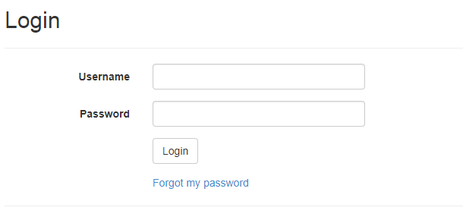

All users must provide their predefined **username** and **password** in order to log in to the system.

Entering their **Username**.  
Entering their **Password**.  
Selecting **Login** to advance to the next screen and begin using the application.

**Forgotten Passwords**   
If users forgot their own credential information, users shall be able to click on “**Forget my password**”

# Logout



All users should be able to log out from their eIDEAS portal any anytime from anywhere.

Click on the “**Logout**” button located on the top right-hand side of the nav bar.

# Search for Ideas

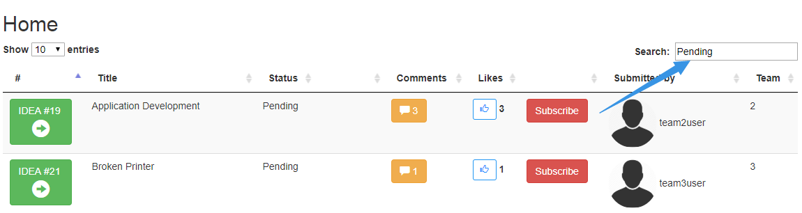

Users should click on the **search** bar located in top right corner of the page.  
Users should write their wanted query **inside** the search bar.  
Users' search results should be **generated dynamically** as they type their query

# Sorting and Filtering Ideas

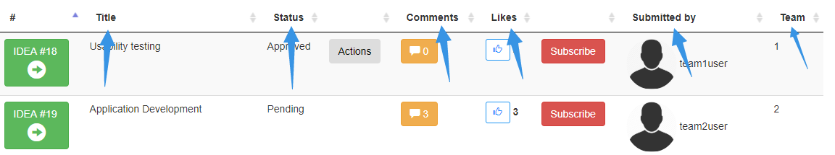

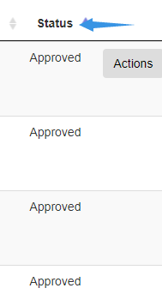

Users should **click** on **column heading** of the column they wish to sort by. Each column can be sorted in **ascending** or **descending** order.

# View Notification Center

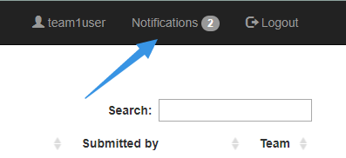

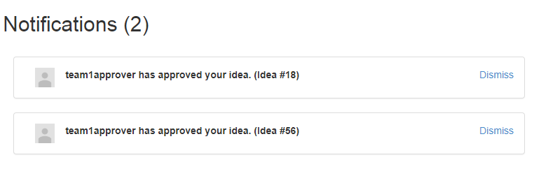

Users should **click** on the **notification icon** which located on the **top right** window.

Users can get rid of old notifications by clicking the “**Dismiss**” link

# View Dashboard

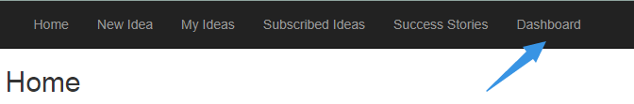

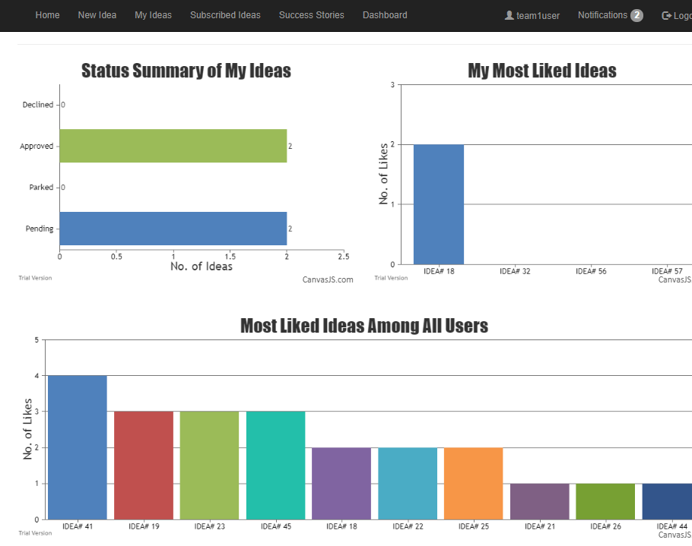

Users should **click** on the “**Dashboard**” tab.

• If the users are **managers**, they should get useful statistical information including but not limited to key performance indicators, budget breakdown, approved ideas by departments (pie chart), and ideas statues (bar chart).  
• If the users are **team members**, they should get useful statistical information including but not limited to idea of the month, and other useful statistical information.

# View Success Stories

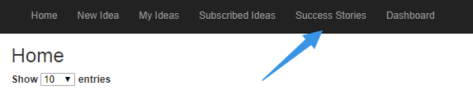

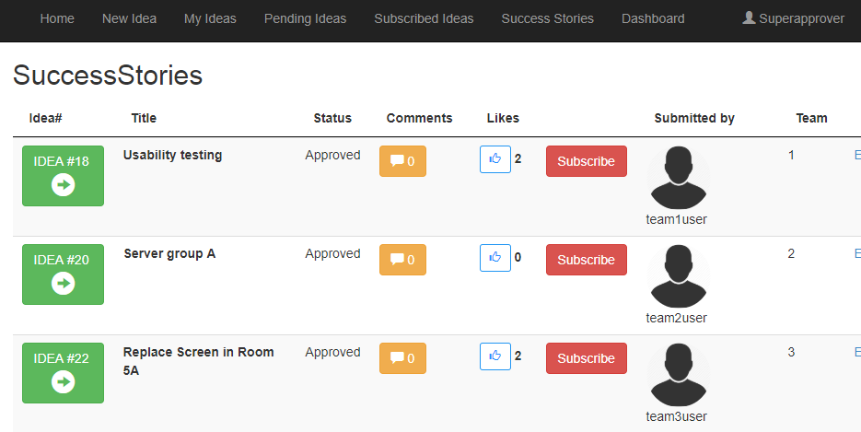

Users should click on the “**Success stories**” tab.

From this page, users can view each idea’s information such as the **owner name**, **idea’s title** and **description**, **comments** and **likes**, and the **rank** that’s been given to the idea submitter.

# Subscribe and View Subscribed Ideas

Users should **click** on the **subscribe** button that appears on the **right** of each idea, except their own ideas.



Users also can **click** on the “**Unsubscribe**” button that appears on the right of each subscribed idea to remove it from the subscription list.

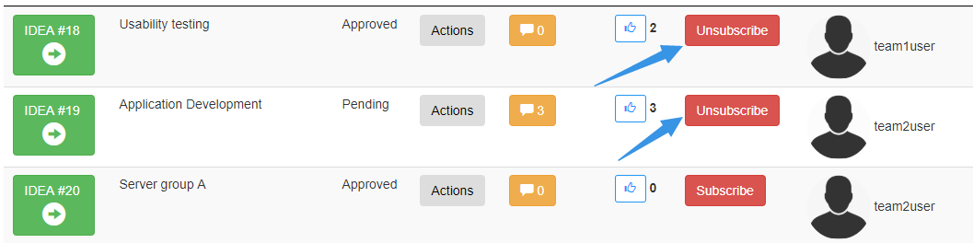

Users should click on “**Subscribed Ideas**” tab. eIDEAS system will show all the ideas that this user has subscribed to.

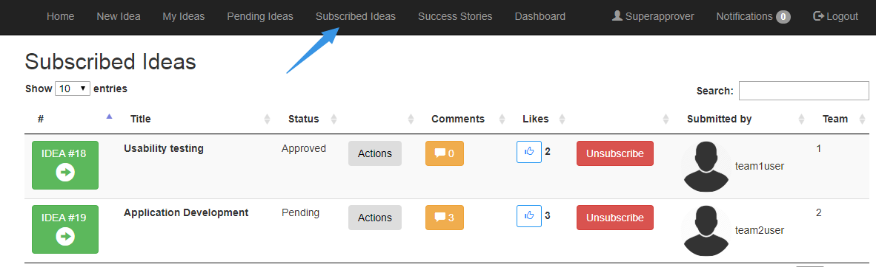

# Give feedback

From each idea box, users can click on the **like icon** to like the idea.

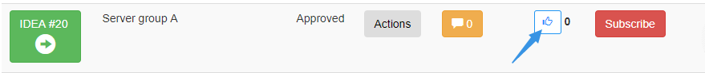

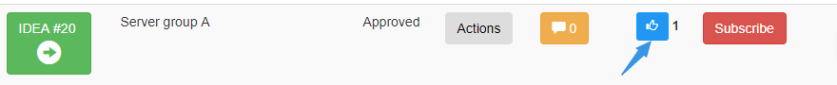

From each idea box, users can click on the **comment icon**.

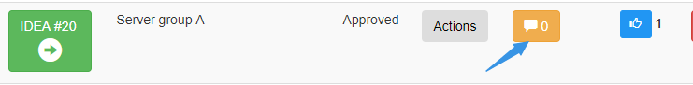

Users can write down their comment in the **text box** then click on the “**Post Comment**”.

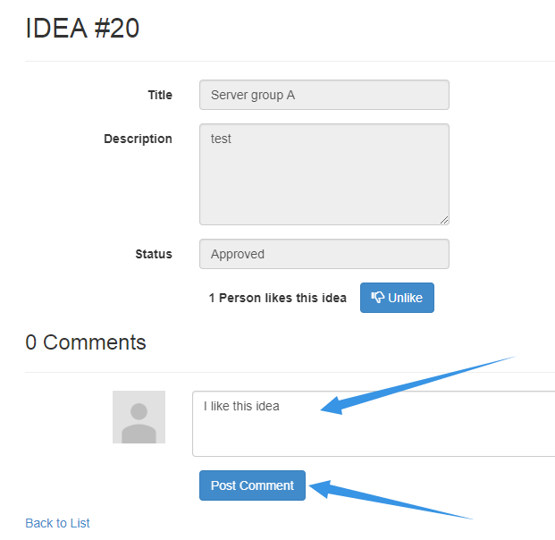

# Add New Idea and View My Ideas

Team members should **click** on the “**New Idea**” tab.

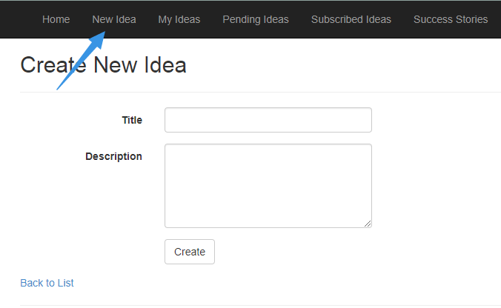

Team members should **click** on the **Create** button once they finish filling up the required information.

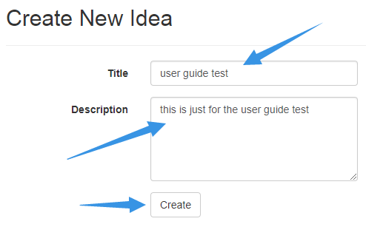

Team members can click on “**My Ideas**” tab in order to view, interact, and give actions on their own ideas.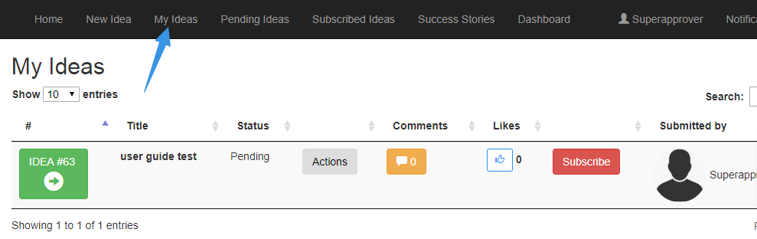

# View pending ideas

Approvers can click on the **Pending ideas** tab to view all the pending ideas.

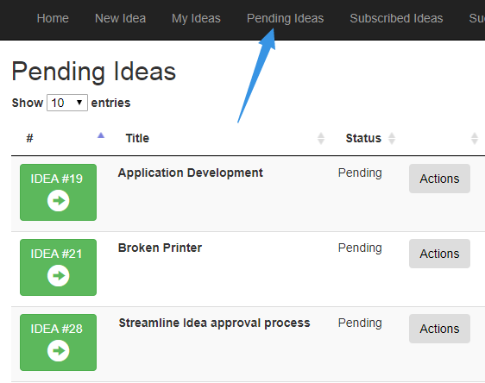

# Give Actions

Users can click on the action **Actions** button which located on the right side of each idea box.

**For the team members**, users can edit, park, decline, delete the idea.

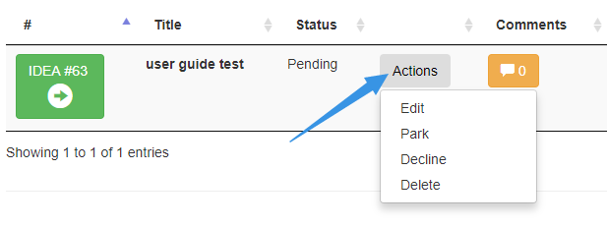

**For the managers/team leaders**. The actions that could be taken are: edit, approve, decline, park, delete the idea

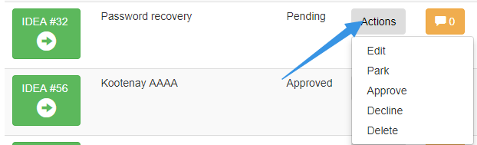

# Technical support team members

**Zain Chowdhary**, Undergraduate Student in Software Systems Engineering,

zain-chowdhary@hotmail.com

**Connor Meredith**, Undergraduate Student in Software Systems Engineering，connor.meredith1@gmail.com

**Demitri Kourles**,Undergraduate Student in Software Systems Engineering,

demitrikourles@gmail.com

**Xiaojie Chen**, Undergraduate Student in Software Systems Engineering,

Natechenfly@gmail.com

**Jinpeng Chen**, Undergraduate Student in Software Systems Engineering,

peng0442@gmail.com

**Shuaihao Zhao**, Undergraduate Student in Software Systems Engineering,

zsh9519@gmail.com